1. What does a neuron compute?

*  A neuron computes an activation function followed by a linear function (z = Wx + b)
*  A neuron computes a linear function (z = Wx + b) followed by an activation function
*  A neuron computes a function g that scales the input x linearly (Wx + b)
*  A neuron computes the mean of all features before applying the output to an activation function

Note: The output of a neuron is a = g(Wx + b) where g is the activation function (sigmoid, tanh, ReLU, ...).

2. Which of these is the "Logistic Loss"?

Note: We are using a cross-entropy loss function.

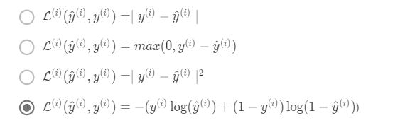

3. Suppose img is a (32,32,3) array, representing a 32x32 image with 3 color channels red, green and blue. How do you reshape this into a column vector?

**Answer: x = img.reshape((32 * 32 * 3, 1))**

4. Consider the two following random arrays "a" and "b":

Consider the two following random arrays "a" and "b":

a = np.random.randn(2, 3) # a.shape = (2, 3)

b = np.random.randn(2, 1) # b.shape = (2, 1)

c = a + b

What will be the shape of "c"?

b (column vector) is copied 3 times so that it can be summed to each column of a. Therefore, **c.shape = (2, 3).**

5. Consider the two following random arrays "a" and "b":

a = np.random.randn(4, 3) # a.shape = (4, 3)

b = np.random.randn(3, 2) # b.shape = (3, 2)

c = a * b

What will be the shape of "c"?

**Answer: "*" operator indicates element-wise multiplication. Element-wise multiplication requires same dimension between two matrices. It's going to be an error.**

6. Suppose you have n_x input features per example. Recall that X = [x^(1) , x^(2)...x^(m)]. What is the dimension of X?

**Answer: (n_x, m)**

Note: A stupid way to validate this is use the formula Z^(l) = W^(l)A^(l) when l = 1, then we have

A^(1) = X

X.shape = (n_x, m)

Z^(1).shape = (n^(1), m)

W^(1).shape = (n^(1), n_x)

7. Recall that np.dot(a,b) performs a matrix multiplication on a and b, whereas a*b performs an element-wise multiplication.

Consider the two following random arrays "a" and "b":

a = np.random.randn(12288, 150) # a.shape = (12288, 150)

b = np.random.randn(150, 45) # b.shape = (150, 45)

c = np.dot(a, b)

What is the shape of c?

**Answer: c.shape = (12288, 45), this is a simple matrix multiplication example.**

8. Consider the following code snippet:

# a.shape = (3,4)

# b.shape = (4,1)

for i in range(3):

for j in range(4):

c[i][j] = a[i][j] + b[j]

How do you vectorize this?

**Answer: c = a + b.T**

9. Consider the following code:

a = np.random.randn(3, 3)

b = np.random.randn(3, 1)

c = a * b

What will be c?

**Answer: This will invoke broadcasting, so b is copied three times to become (3,3), and ∗ is an element-wise product so c.shape = (3, 3).**

Q10. Consider the following computation graph.

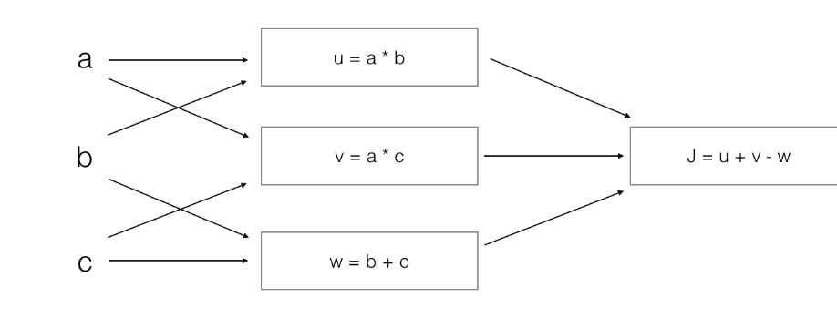

J = u + v - w

= a * b + a * c - (b + c)

= a * (b + c) - (b + c)

= (a - 1) * (b + c)

**Answer: (a - 1) * (b + c)**